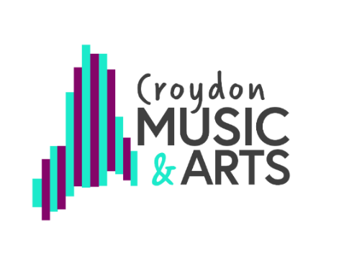
RSL Star Award (Star 1)

Assessment task: Your Story Your Heritage

Time to get the adults involved and remind them they were children once! As part of your RSL Star Award (Star 1) we would like you to ask an adult in your family to teach you something that they learned as a child. It should be something traditional like a song or dance that other children their age would have known as well. If your parents or grandparents grew up in another part of the UK, or in another country, ask them about that place.

Here are some examples of what you could learn from someone in your family:
- A traditional song
- A traditional story or poem
- A traditional dance
- More information about a festival they celebrate

For your Star Award assessment task, share what you learned with your teacher. You can do this in one of two ways, either:

- Share the information with your teacher in your lesson
- Send your teacher a short video

If you have learned about a song, dance or poem you should present some of that in the video or to your teacher. If it was a story, say something about the main characters. If it is a festival, why is it important to the adult you spoke to?

